# IPv6 Lab

**IPv6 Lab**

This lab we will use GNS3 with the IOU Router.

**Tools and Materials**

1. GNS3 VM
2. Your company has been assigned the following IPv6 prefix 2001:0FCE:0004::/48.

In GNS3 create the following network topology.

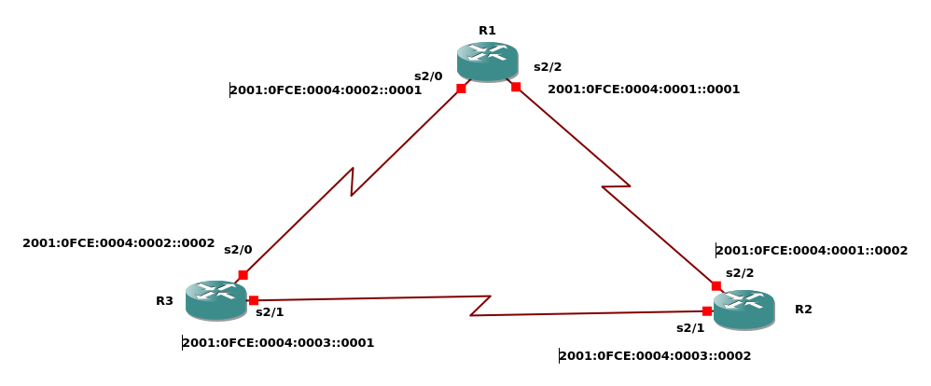

1. Connect to each of the routers and enable IPv6 routing. (**Grading: 30 points**)
2. Assign the indicated IPv6 addresses to each of the interfaces. (Remember to enable each of the interfaces) (**Grading: 5 points per interface**)
3. Test each interface by executing a ping from one end of the interface to the other end. You need to perform a total of 3 pings. **(Grading: See #4)**
4. Take a screenshot of each ping and paste it into the lab writeup document. Make sure to identify which link you are testing. **(Grading: 10 points per ping with screenshot)**
5. Stop the simulation and export it to a portable project. (Make sure you don’t include the image) **(Grading: 10 points)**
6. Submit the screenshots and the portable project on Canvas.